**Proposal for Online Payment Fraud Detection Using Machine Learning**

***Presented by Eng/* Abdullah Nabil**

***To Eng/* Tarek Ziad**

**Project Overview**

Online Payment Fraud Detection is critical in modern financial systems due to the increase in online transactions. The goal of this project is to develop a machine learning model that can accurately detect fraudulent transactions, ensuring the safety of online payments and protecting users from financial losses.

**Objectives**

**1. Data Understanding and Visualization:** Analyze and visualize the dataset to understand the underlying patterns and relationships between features.

**2. Data Preprocessing**:Clean and preprocess the data to make it suitable for model training.

**3. Feature Engineering:**Transform and create relevant features to improve the model’s performance.

**4. Model Training and Evaluation:**Train various machine learning models and evaluate their performance using appropriate metrics.

**5. Model Deployment:** Develop a pipeline to deploy the model for real-time fraud detection.

**Dataset**

The dataset contains the following columns:

**- `step`:** Time unit of the transaction.

**- `type`:** Type of transaction.

**- `amount`:** Total amount of the transaction.

**- `nameOrig`:** Account initiating the transaction.

**- `oldbalanceOrg`:** Initial balance of the sender’s account.

**- `newbalanceOrg`:** Balance of the sender’s account after the transaction.

**- `nameDest`:** Account receiving the transaction.

**- `oldbalanceDest`:** Initial balance of the receiver’s account.

**- `newbalanceDest`:** Balance of the receiver’s account after the transaction.

**- `isFraud`:** Target variable indicating whether the transaction is fraudulent (1) or not (0)

**Data Information:**

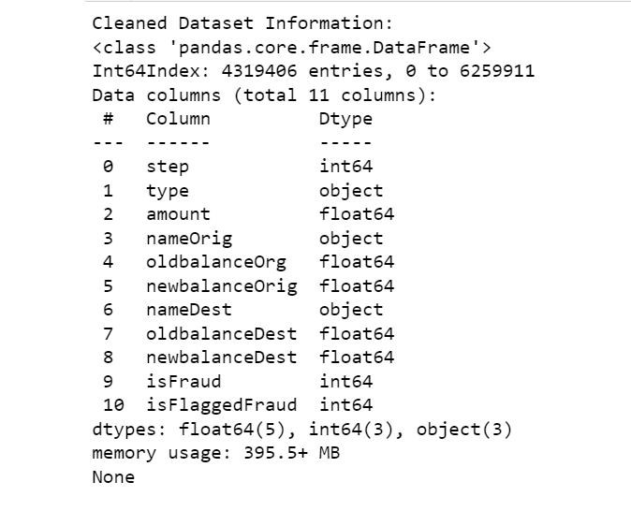

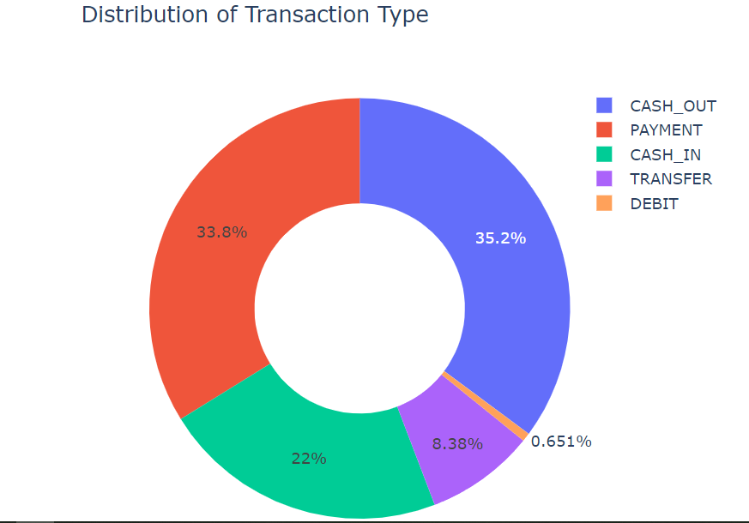

**Data Information (Cont.):**

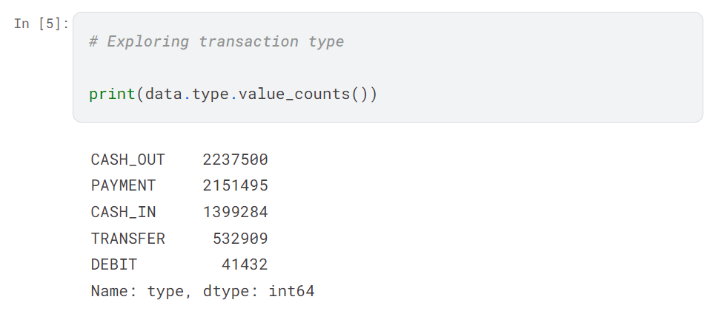

**Data overview:**

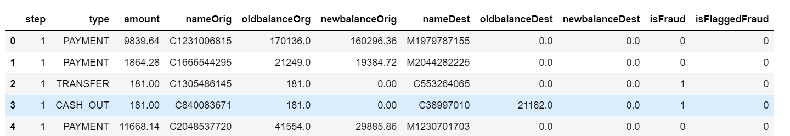

# Reference: The dataset used for this project is available at:

# https://www.kaggle.com/datasets/jainilcoder/online-payment-fraud-detection/code